**GeddesPhysics**



**Sequoyah High School**

**AP Physics C**

**Rotational Motion Lab**

**Objectives:**

* Measure the translational acceleration of a object falling from a pulley (as illustrated in the figure below), and
* Use the measured acceleration to analyze the validity of assumption that the pulley exhibits rotational inertia consistent with a disk (*I* = ½ MR2).



**Equipment:**

Pulley, hanging mass, motion detector with CBL data acquisition system.

**Background:**

Most rotational motion problems involving an object falling from a pulley advise the solver to assume that the pulley exhibits the rotational inertia of a disk:

(1)



 To verify the validity of this assumption, one could measure the translational acceleration of the falling object and relate this acceleration to the angular acceleration of the pulley. After determining the angular acceleration of the pulley, applying Newton’s Second Law for Rotational Motion (equation 2) would yield an empirical value for the rotational inertia of the pulley.

(2)



The torque is provided by the weight of the falling object located a distance R from the axis of rotation of the pulley. Translational acceleration of the falling object can be determined by obtaining distance and time data.

**Experimental Procedure:**

Things to consider while developing the procedure:

* Is the acceleration of the falling object constant? If so, constant acceleration formulas may be applied.
* How will you obtain distance and time data? Once the data are collected, how will you graph them to yield acceleration?

**Conclusion:**

Your conclusion should address the translational acceleration of the block and relate this value to the angular acceleration of the pulley. The conclusion should also compare the percent difference between the calculated moment of inertia and the moment of inertia that would be obtained from the disk formula (equation 1).

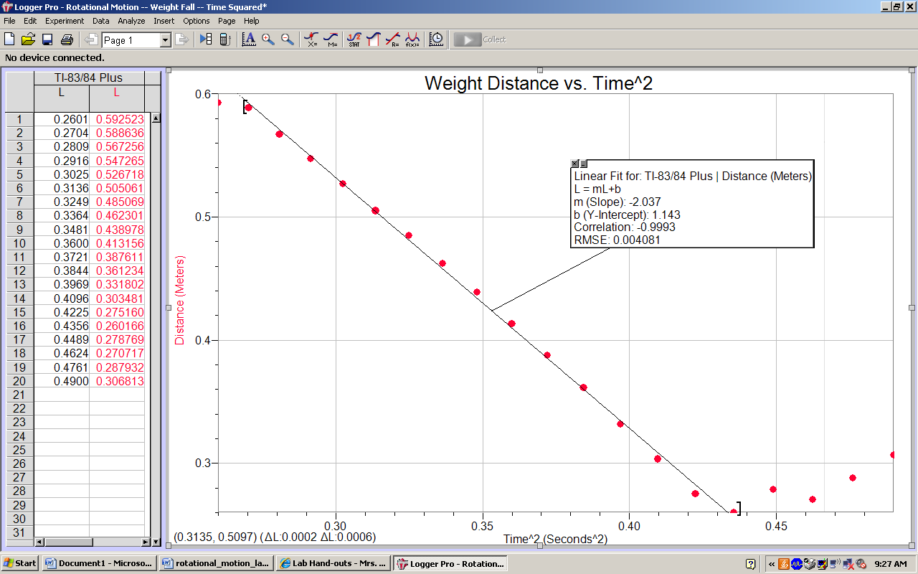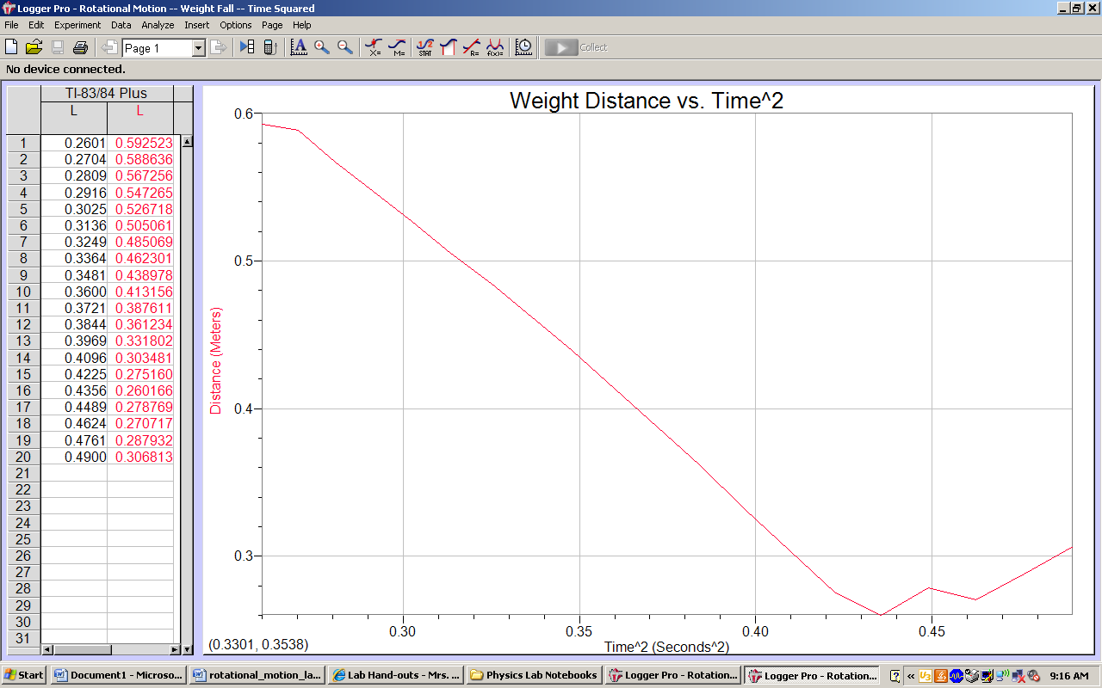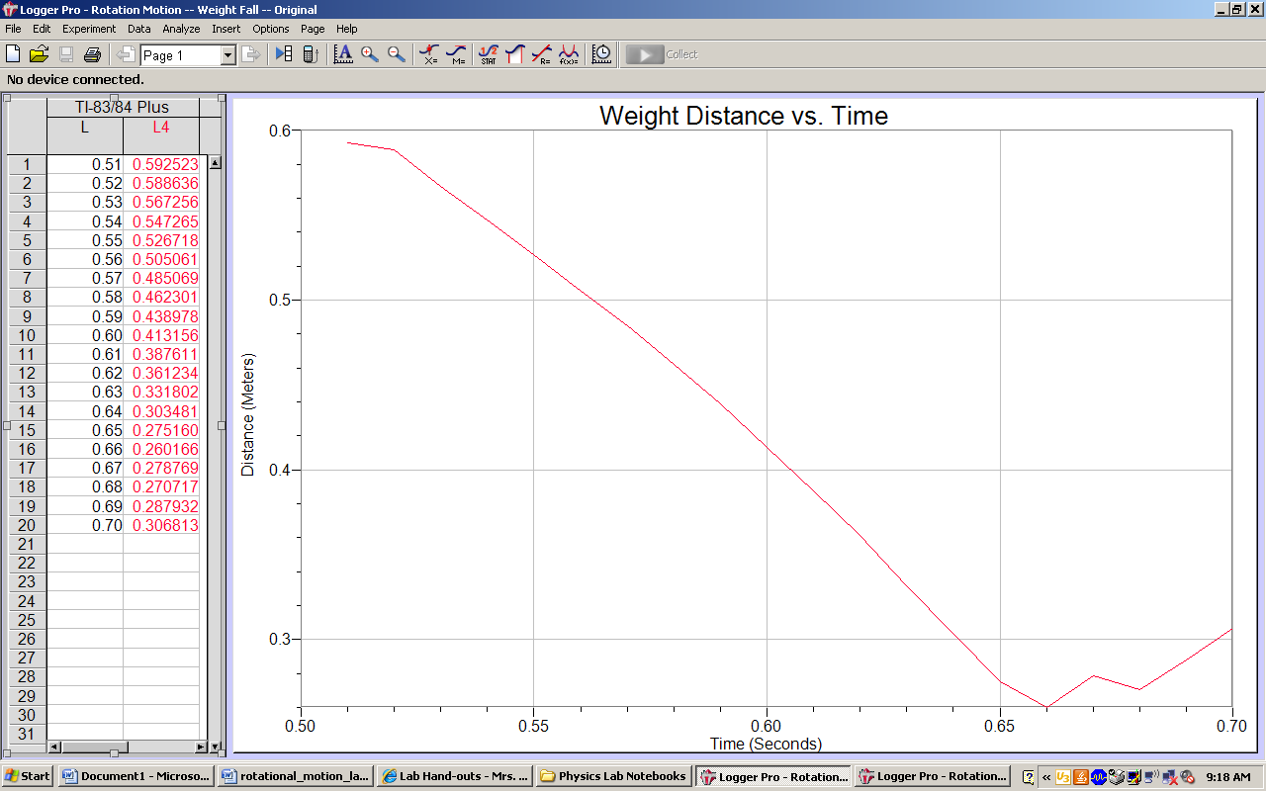

1) Purpose: Measure the translational acceleration of a object falling from a pulley (as illustrated in the figure in the rubric above), and use the measured acceleration to analyze the validity of assumption that the pulley exhibits rotational inertia consistent with a disk (*I* = ½ MR2).

2) Equipment: weight= .1 kg, twine, pulley, stand, accelerometer a measuring stick

3) Procedure: we tied the string to the pulley on one end and the weight on the other with the accelerometer set up below that. Then we wound the string around the pulley turned the accelerometer on and dropped the weight. Once we have the data we transferred it to the computer and created the graphs above. Using those graphs and taking measurements we were able to come up with the values of the variables we needed to solve for the moments of inertia of the pulley.

4) Data: above +

m = mass of the pulley = .0132kg

mw = mass of the weight = .1 kg

r = radius of the pulley = .02156m

g = acceleration due to gravity = 9.81m/s2

at = transitional acceleration = |slope of graph *2| =| -2.037*2| = 4.074 m/s

5) Data Analysis:

Icalc=(mwgr2)/at  = 1.1192*10-4

Idish=.5mr2 = 3.0679*10-6

(Idish-Icalc)/((Idish+Icalc)/2)*100 = %difference = -189.3279%

6) Conclusions: The transitional acceleration is 4.074 m/s and the experimental moment of inertia was 189% off the value that it was suppose to exhibit. This error could be due to the air resistance created by card we attached to the bottom of the weight so that the accelerometer picked it up, the mass of the string we used and the width of the string affecting the radius, errors on the drop (accidentally moving the pulley when letting go), and friction that was present with the pulley.